GUIDELINES for PARENTS of GRADUATES with LATIN HONORS

- Gate Entry. All parents shall enter thru the Main Lobby Entrance of PICC.

  - Seating Arrangement. The 2 parents/guests of graduates with Latin Honors will have reserved seats at the front left portion of the Plenary Hall (when facing the stage). A seating arrangement shall be provided for this purpose. The seating arrangement of parents/guests will be based on the alphabetical list of graduates with Latin honors per degree program, per institute. (Please refer to the Commencement Exercises program.)

- Awarding of Medals. An area on the left side of the main stage (when facing the stage) will be provided for the awarding of medals for graduates with Latin Honors. Guidelines are as follows:

  - The honor or special award/s will be announced by the program head as the names of graduates are called to receive their diploma at the main stage.
  - The medal/s will be handed by the Institute dean to the graduate together with the diploma.
  - Upon descent/exit from the main stage, the honor graduate will proceed to the area where his/her parents/guests are waiting. Parents/guests will approach the area for awarding of medals from the left side, while the honor graduate shall approach the area from the right side (Please refer to the sketch below).
  - The 2 parents/guests will award the medal/s. Marshals will be around to guide the parents/guests.

- Time Allotment for Photo Ops. A time allotment of 10 seconds (maximum) will be provided for a photo opportunity after the awarding of medals for each honor graduate. Beyond this time allotment, the marshal in-charge will immediately usher the graduate and the parents/guests back to their seats. The maximum allotted time is important to ensure the smooth flow of the program and to avoid unnecessary human traffic.

We respectfully enjoin your full cooperation to ensure a solemn graduation ceremony.

Congratulations!

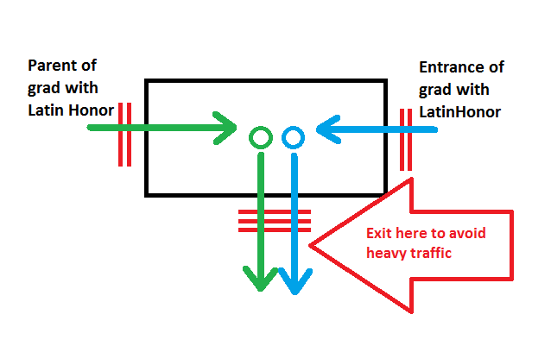

Sketch of the area for awarding medals

C O N F O R M E

I, _______________________________________ of section _____________________ received, read, and fully understood the provisions stated in the GUIDELINES for PARENTS of GRADUATES with LATIN HONORS. I do hereby express my commitment to comply with the University rules and regulations and those stated in the Guidelines. Far Eastern University reserves the right to take disciplinary action if I violate any of the University rules and regulations and those stated in the Guidelines.

___________________________________ ___________________________________
Student’s Signature over Printed Name Parent’s Signature over Printed Name

Date: __________________ Date: _____________________

