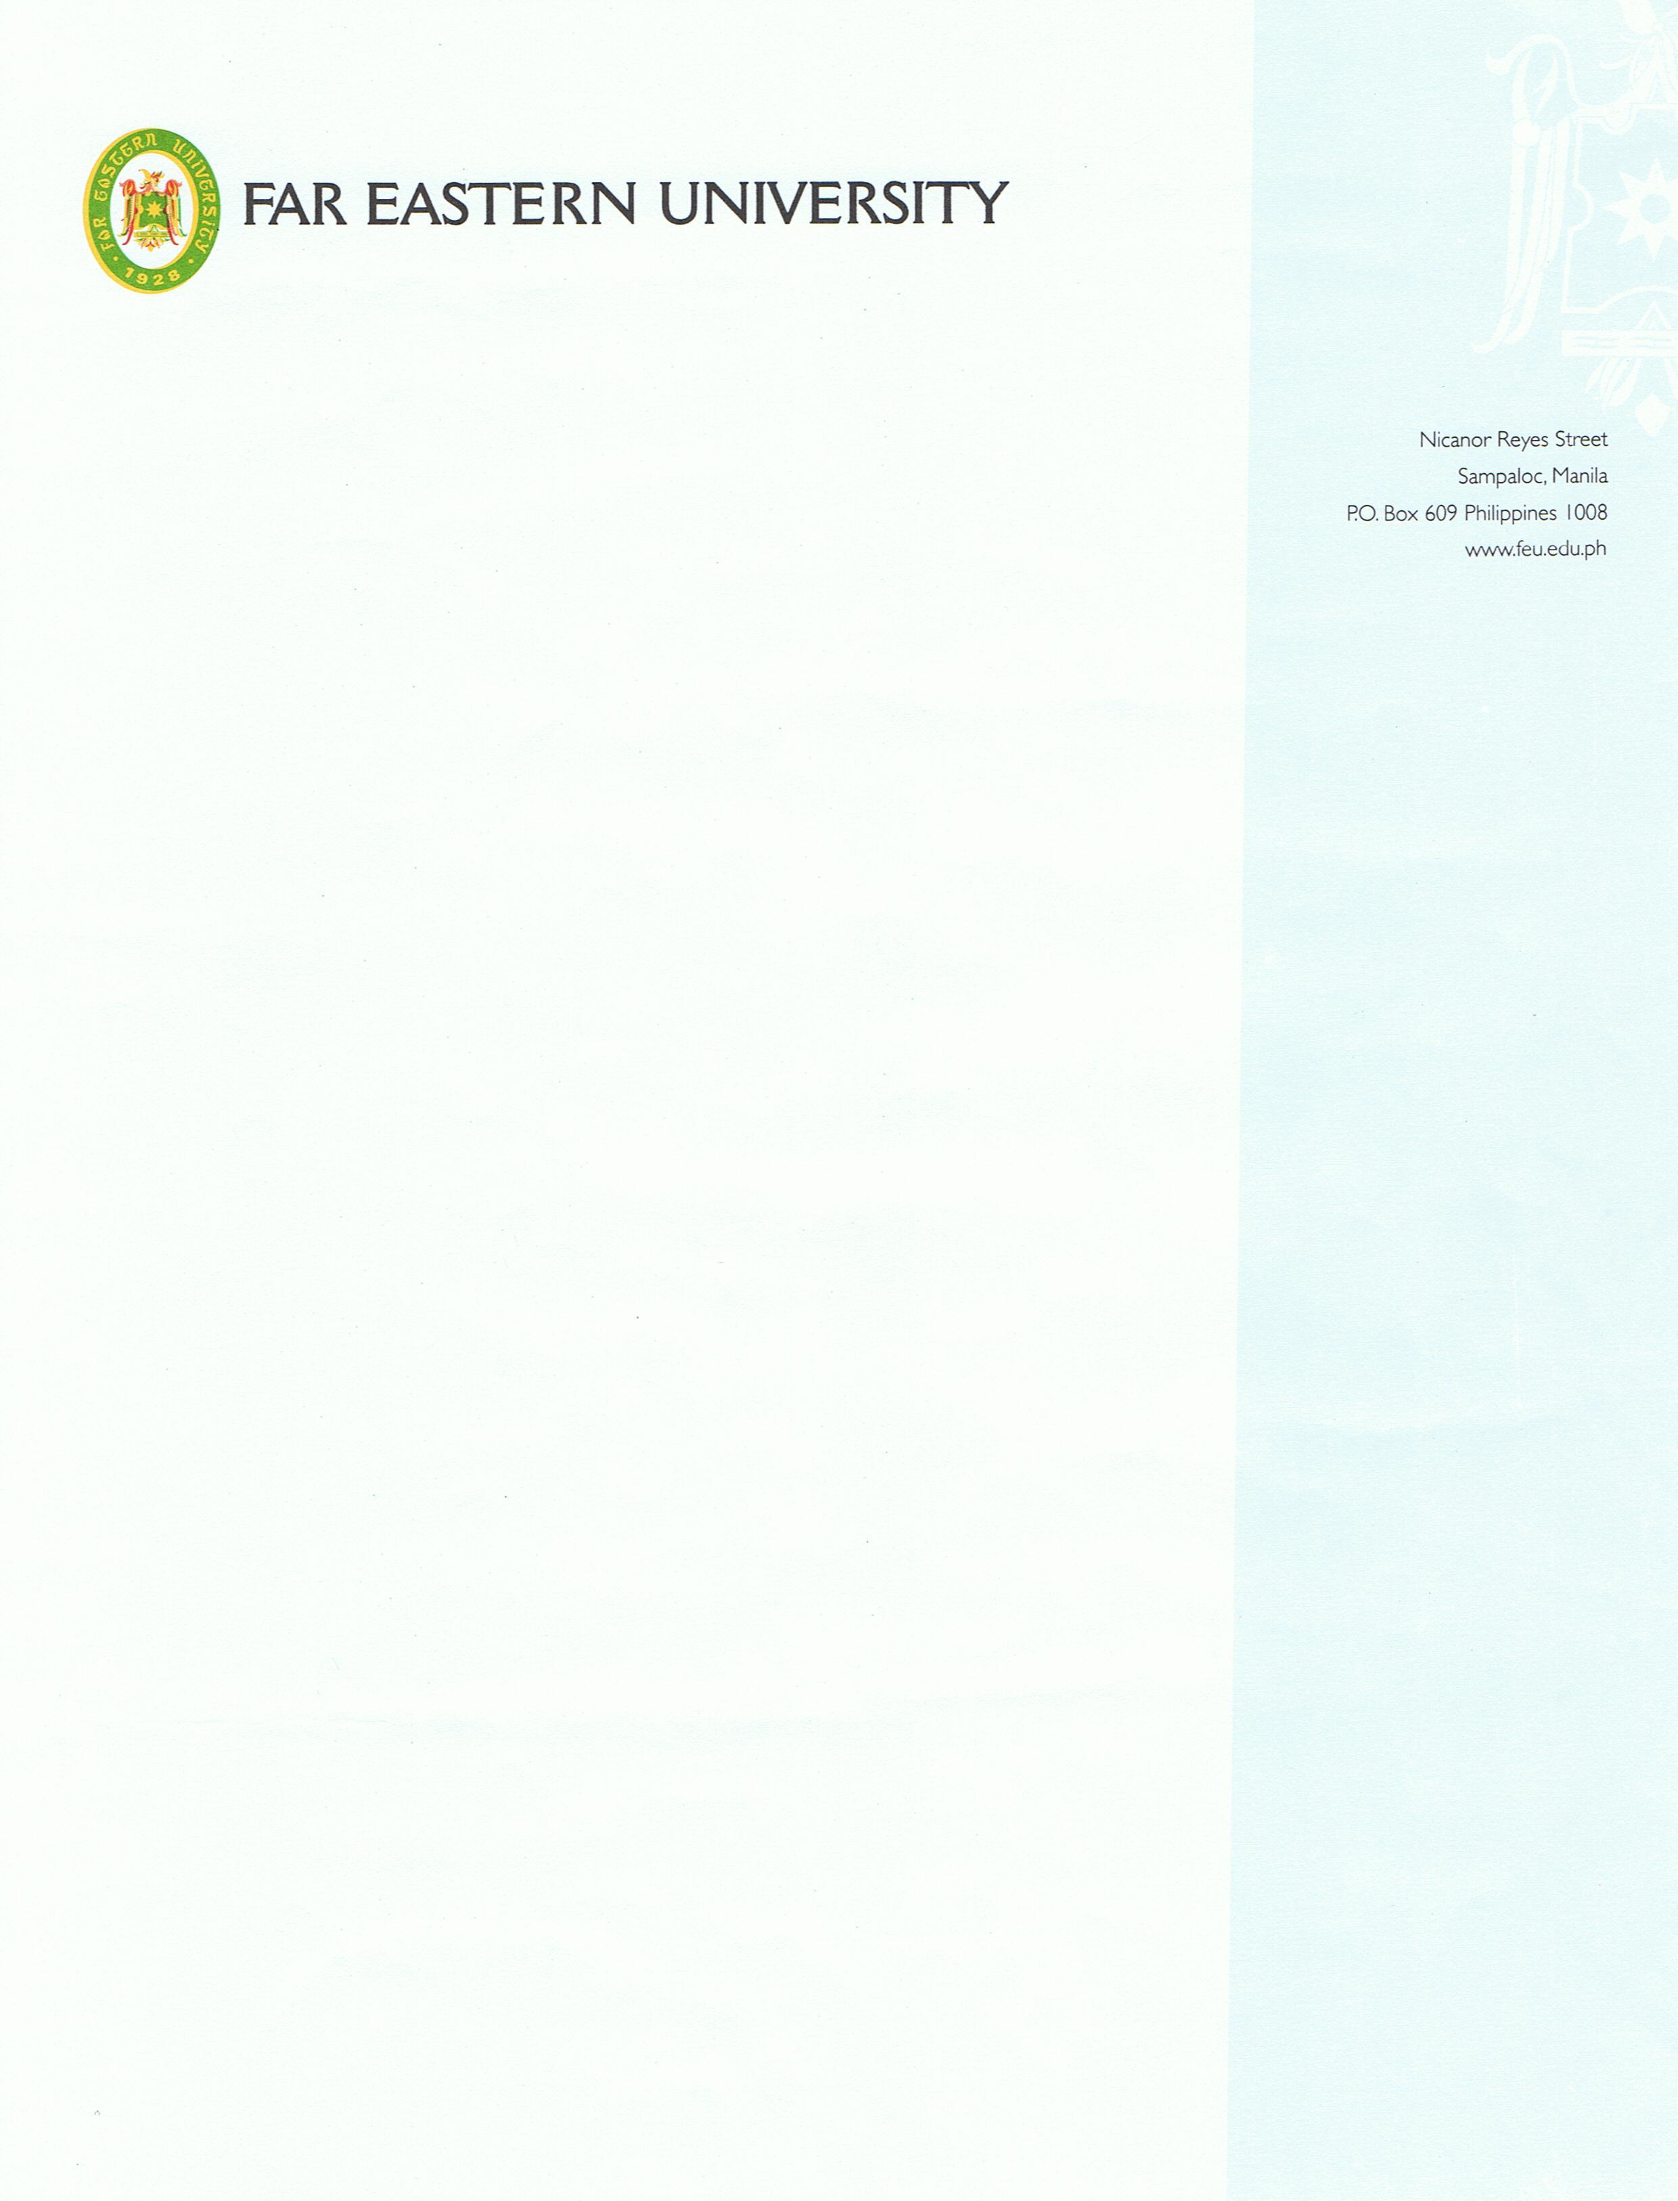

____________________________

Dear Faculty Members Concerned:

Kindly excuse the attached list of students because they will conduct their Technical Dress Rehearsal (TDR) on _____________________ and their Final Theater Production on _________________________at the DepComm Studio Theatre, from 8:00am to 8:30pm.

Enrolled in the course DRM 102 (Theater Direction & Production), the students need to have extensive collaboration and rehearsal to successfully mount the production.

Kindly give them due consideration by way of requirements that will offset any classroom activity they will miss.

A favorable response will be highly appreciated.

Thank you.

Sincerely,

______________________________
Faculty, DRM 102

Noted:

Cherish Aileen Brillon
Program Head

Dr. Joel M. Chavez
Dean, IAS

